**Week 10**

**Creating Stored Procedures & Triggers**

**AIM: Implement Sub Programs (Stored Procedures) in PL/SQL.**

**1. Create a Procedure, which receives employee number and displays employee name, Designation and salary.**

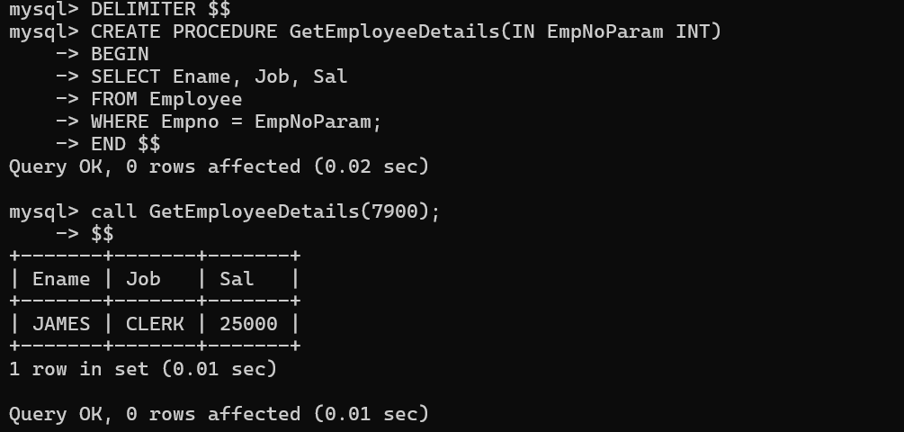

**2. Create a procedure, which accepts employee number and returns employee name and department name in an out parameter.**

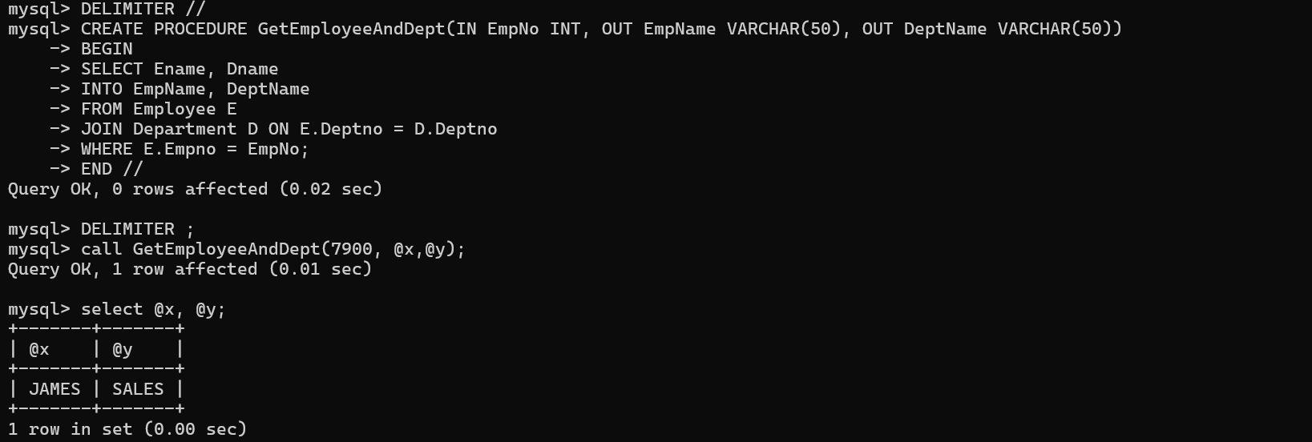

**3. Create a procedure, which takes the department number and gets the total salary of that department.**

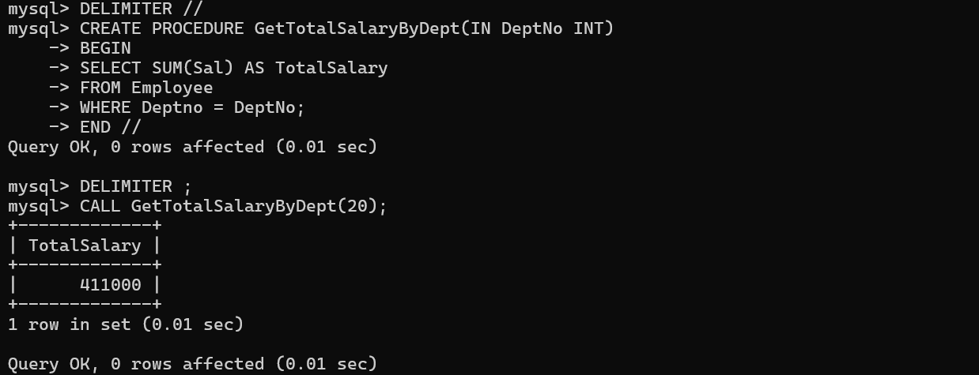

**4. Create a procedure to accept Department number and display Name, Designation, Sal and Deptno of each employee belonging to such Department.**

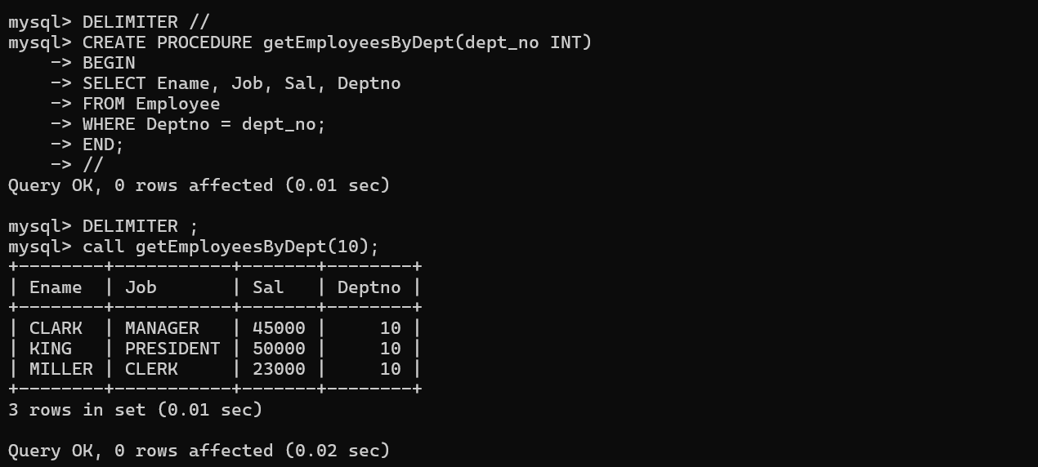

**5. Create a procedure to get a cube of a passed number.**

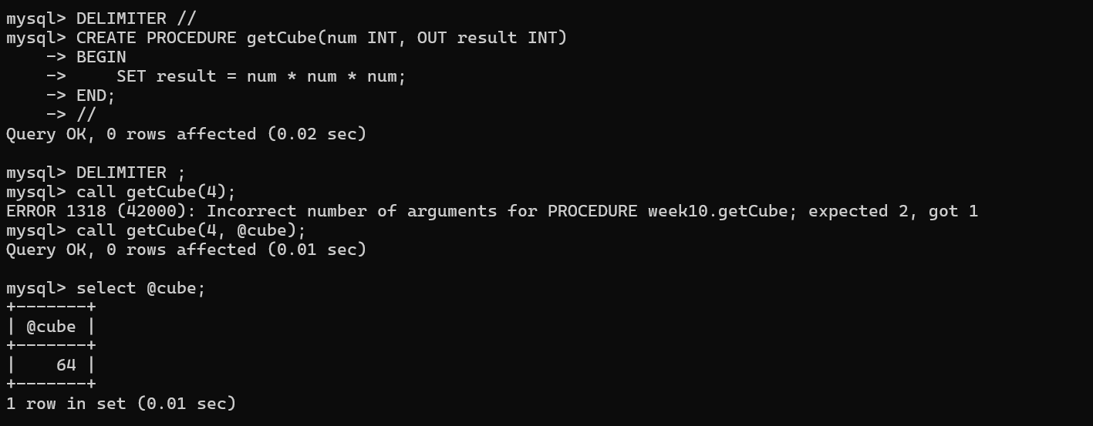

**6. Create a procedure to find out the maximum salary for the passed designation.**

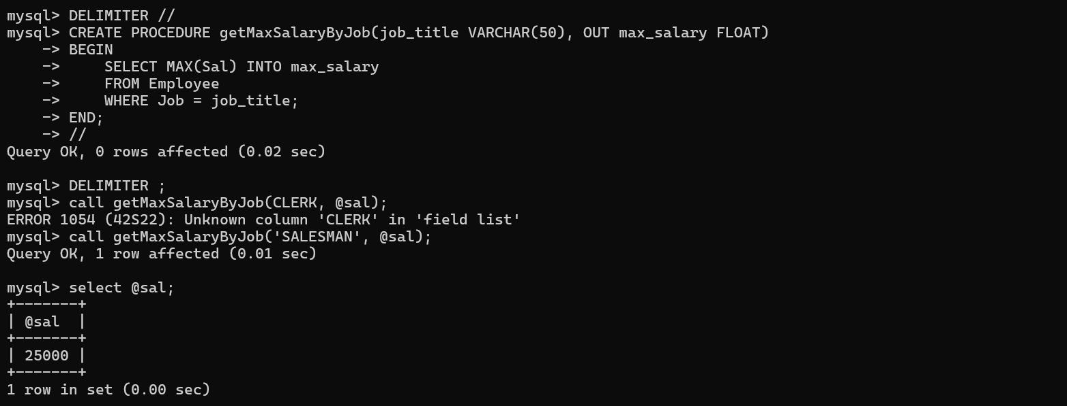

**7. Create a procedure to find out Total salary for the passed department Name**

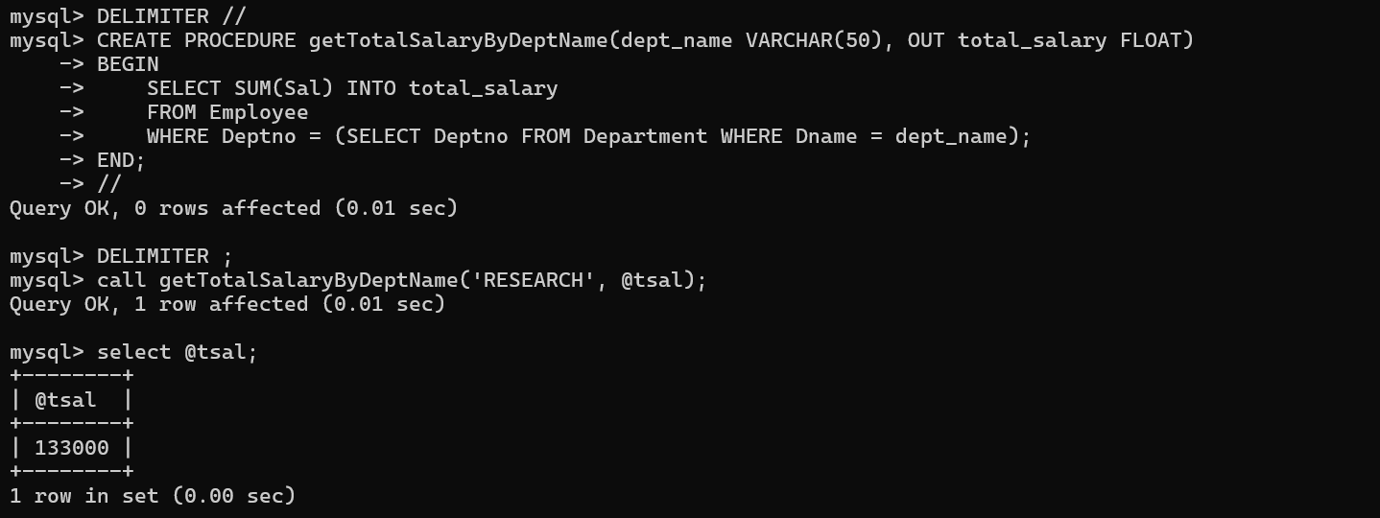

**8. Create a procedure to check whether the passed number is Odd or Even.**

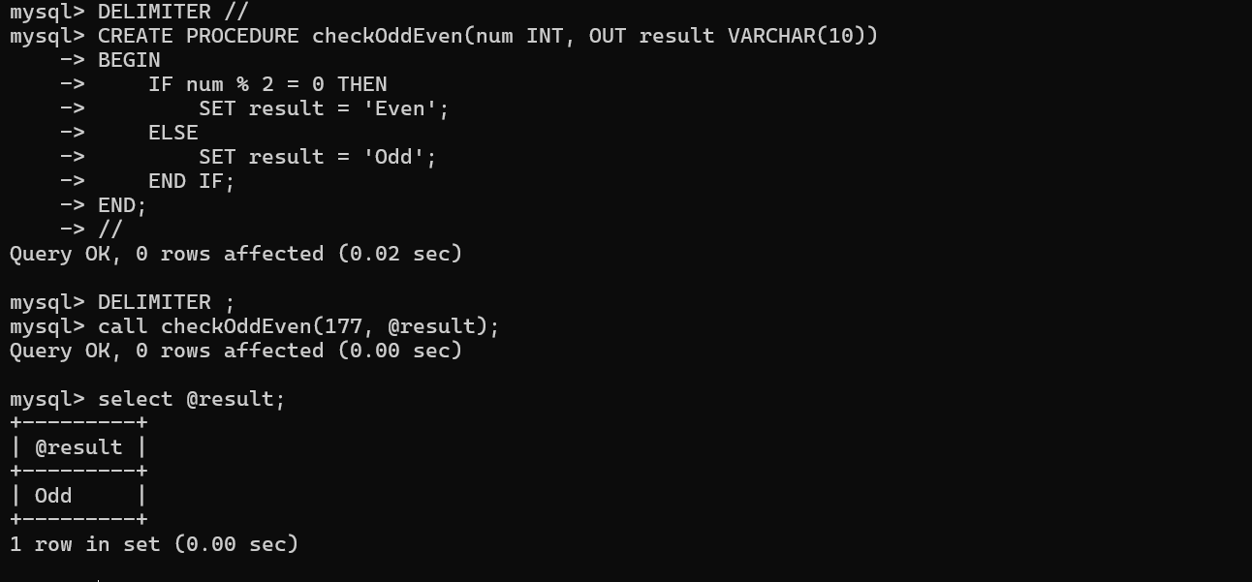

**9. Create a procedure to find out total annual income for the employee, who’s number we passed as argument.**

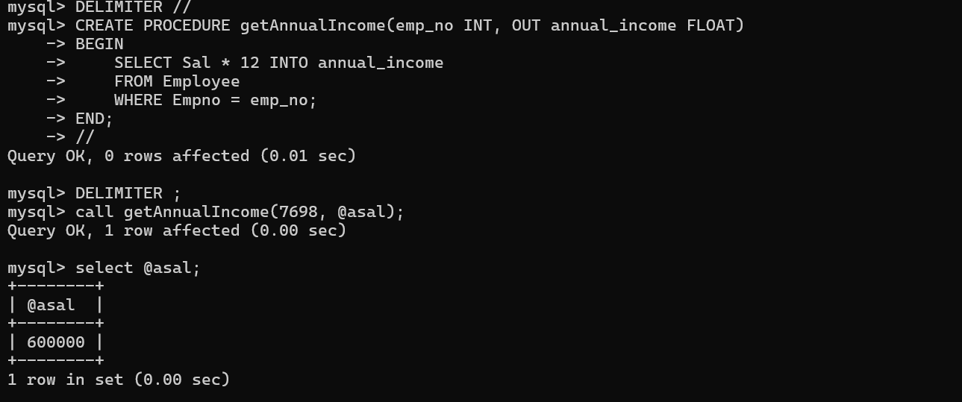

**10. Create a procedure, accept 2 numbers as input, and operator also input and the result as output.**

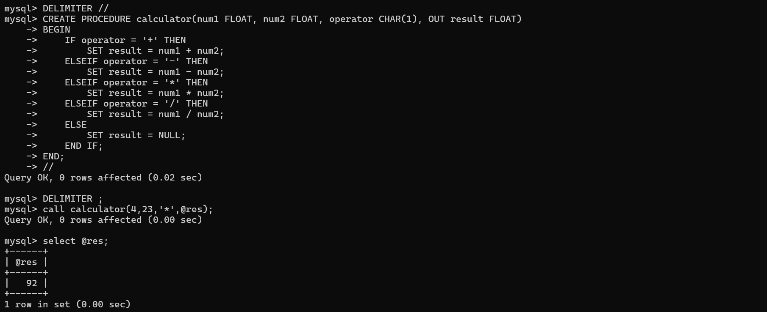

**Problem 1: Log Deleted Employee Records**

**Objective: Create a trigger that logs any deletion of employee records into a separate log table to keep track of deletions for auditing purposes.**

**Context: To maintain a history of deleted employees for audit and analysis purposes, the company wants to store a record every time an employee is deleted. This record should include the employee's number, name, and the timestamp of when the deletion occurred.**

**Task:**

1. **Create a table named EmpLog that will store deleted employee information.**
   * **The table should have the following columns:**
     + **ActionType (VARCHAR): This should store a string indicating the action performed ('DELETE' in this case).**
     + **Empno (INT): Employee number.**
     + **Ename (VARCHAR): Employee name.**
     + **ActionDate (DATETIME): Timestamp when the action was performed.**
2. **Create a trigger named EMP_DELETED_DATA that automatically inserts a record into the EmpLog table every time an employee is deleted from the Employee table.**
   * **The ActionType should be set to 'DELETE'.**
   * **The Empno and Ename should be retrieved from the deleted record.**
   * **The ActionDate should be the current timestamp.**

**Testing:**

1. **Delete an employee record from the Employee table.**
2. **Check the EmpLog table to verify that the deleted employee's information is stored correctly.**

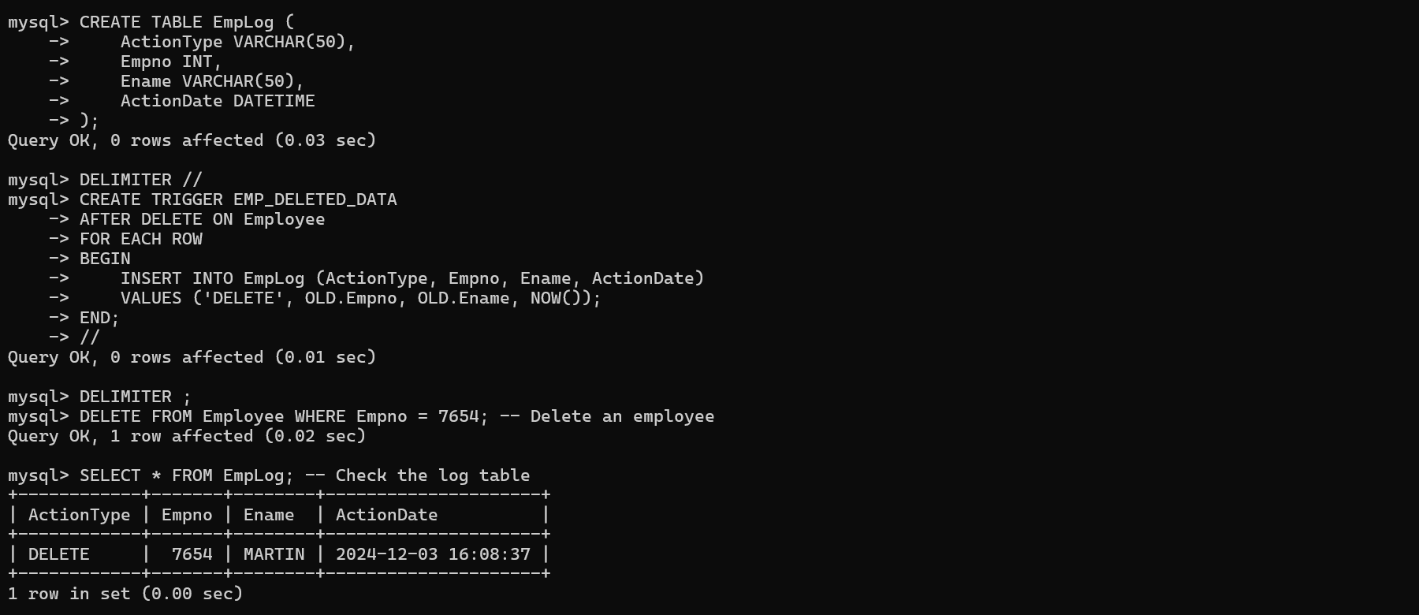

**Problem 2: Track Employee Salary Updates**

Objective: Create a trigger that logs any changes to an employee's salary.

Task:

1. Create a table named SalaryHistory with the following columns:
   * Empno (INT)
   * OldSalary (FLOAT)
   * NewSalary (FLOAT)
   * ChangeDate (DATETIME)
2. Create a trigger named TrackSalaryUpdates that will insert a record into SalaryHistory every time the Sal column in the Employee table is updated.

Testing:

1. Update the salary of an employee to see the changes tracked in SalaryHistory.
2. View the contents of the SalaryHistory table.

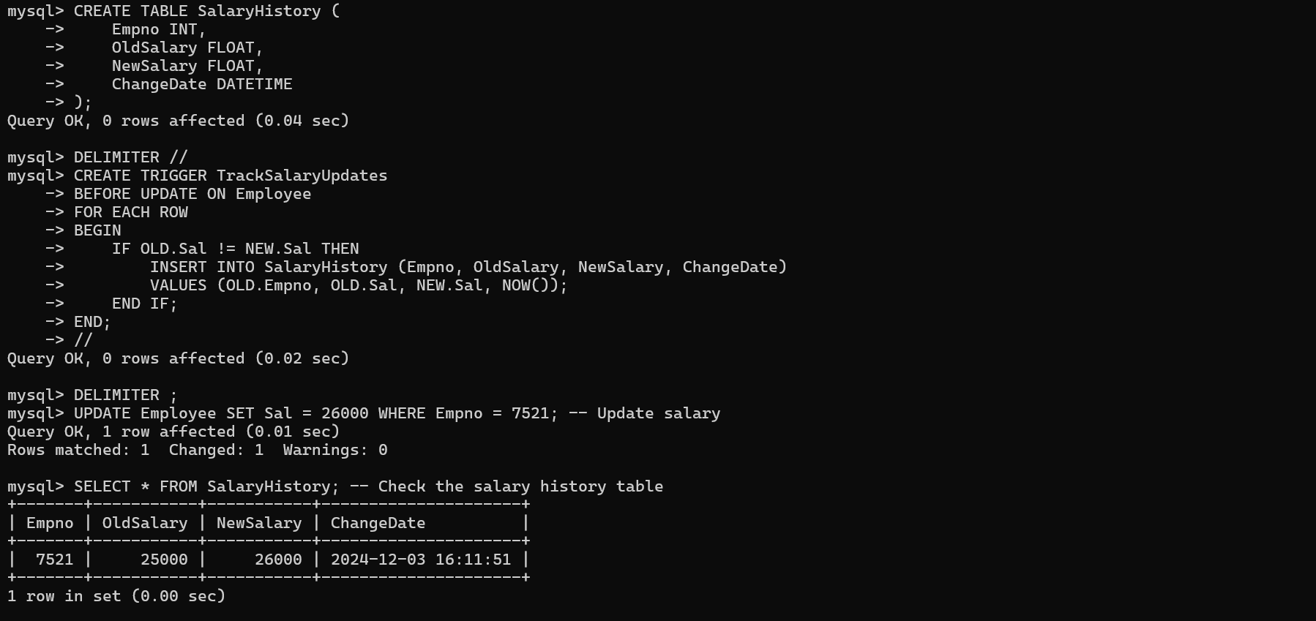

**Problem 3: Automatically Update Department Count**

Objective: Keep track of the number of employees in each department automatically whenever employees are added or removed.

Task:

1. Create a table named DepartmentCount with the following columns:
   * Deptno (INT)
   * EmployeeCount (INT)
2. Write triggers to automatically update the EmployeeCount whenever an employee is inserted or deleted in the Employee table.

